Forecasting and Clustering
Implementing Clustering
Statement:
Using the “Student Academic Data.xlsx”, create segments of Good, Average and Bad performance in “Math test” and “Writing test”.
Solution:
Clustering in Tableau helps you create statistically based segments which provides insights on how different groups are similar as well as how they perform when compared to each other. Tableau uses the k-means clustering method to create a cluster and Lloyd’s algorithm with squared Euclidean distances are used to compute the k-means clustering for each k.

Let us get started with the Student Performance report:
Step 1: Click on Connect → Microsoft Excel → Student Academic Data.xlsx →Sheet1 (Rename it to Student Performance Analysis)
Step 2: Data pane → Measures → Drag Math’s score and Writing Score to Column and Row shelf respectively.
Step 3: To create cluster:
Data pane → Analytics → Models → Clusters → Drag and drop Cluster on view.

- Tableau creates cluster groups on colours (marks card), and colours the marks in our groups by cluster. Tableau assigns each value in the view to one of the clusters and if some values do not fit well in clusters, they are assigned to “Not Clustered” cluster. In this view, red, blue and orange clusters represent high, average and low performance of students in Maths and Writing tests.

- Tableau displays the Clusters dialog box, which can be customised adding variables fromthe data pane to the cluster dialog box in variables section. You can assign the numbers of clusters or just choose the automatic option.

Step 4: To view the clustered data in detail:
Marks Card → Cluster → Drop down → Describe
- You can copy this data to clipboard and use it for further in-depth analysis.

Step 5: Let us make our visualization more interactive by renaming the clusters:
Marks card → Drag “Cluster” to Data pane → Student ID cluster → Drop down

Drop down → Edit group → Edit Group dialog box → Change:
- Field Name: Student Performance
- Groups: Cluster 1 → Rename → Average
Cluster 2 → Rename → Bad
Cluster 3 → Rename → Good
- Apply→ OK

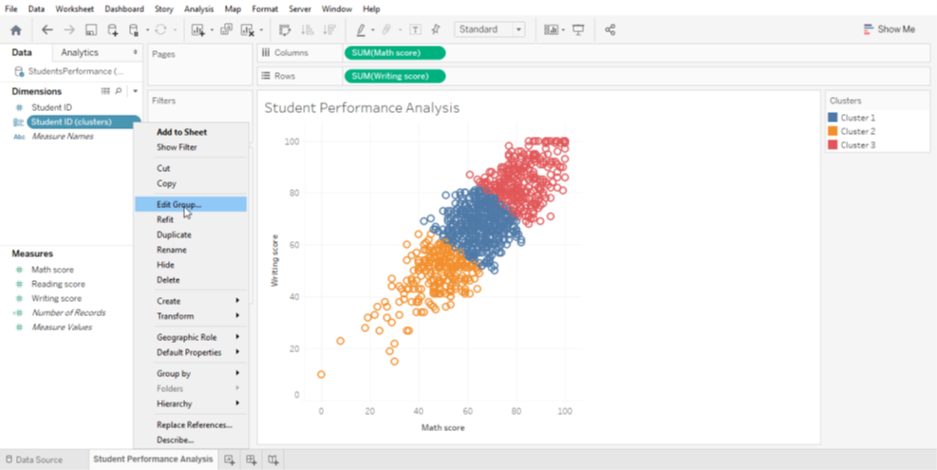

- Here, we have Student’s performance in Maths and Writing tests categorized into Good, Average and Bad clusters.

